2018 Inspiration Award
Nomination Form

Each year, the Colorado Association for School-Based Health Care (CASBHC) recognizes outstanding school-based health center providers and partners. The 2018 awards will be presented at a lunch on Monday, April 30, in conjunction with the CASBHC annual conference in Black Hawk, Colorado.

There are five award categories. Only one nomination per category will be permitted from the same nominating party. Past Inspiration Award recipients are not eligible for the same award twice.

Deadline for submissions is January 31 at 5pm. For inquiries, contact Stacey Moody, at 303-350-4294 or by email at moody@casbhc.org.
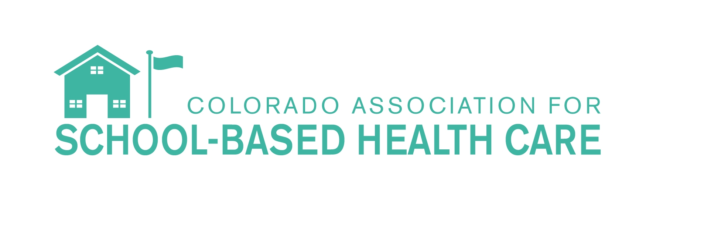

Officially submit one of these ways:
- By email to Stacey Moody at moody@casbhc.org
- Via Survey Monkey at https://www.surveymonkey.com/r/INSPIRATION2018

Date:Click or tap to enter a date.

Your Name/ TitleClick or tap here to enter text.

Organization or school/district:Click or tap here to enter text.

Email:Click or tap here to enter text.

Phone:Click or tap here to enter text.

Nomination CategoryClick or tap here to enter text.
(see categories below)

Lifetime Achievement Award
- Individual who has dedicated at least 20 years to child/adolescent/school health
- Individual who has been instrumental in implementing change in school health
- Individual who is respected and revered by peers
- Individual who is seen as a leader and pioneer in the field

Outstanding Individual School-Based Health Center Provider
- Includes medical, behavioral or dental provider
- Individual demonstrates effectiveness with students, outstanding leadership qualities, and excellent collaboration with team members
- Individual goes above and beyond regular duties

Outstanding Individual School-Based Health Center Administrator
- Individual implements improvements in the delivery of services and sustainability of the program
- Individual demonstrates outstanding leadership qualities, excellent collaboration with team members, and successful outcomes
- Individual goes above and beyond regular duties

Outstanding School Health Professional or Educator
- Includes school administrators, school social workers, school nurses, school psychologists, health aids, outreach and enrollment technicians, and health educators
- Individual demonstrates ability to integrate services effectively, communicates well with students, has outstanding leadership qualities, and collaborates with team members
- Individual goes above and beyond regular duties

Outstanding Community Partner or Champion
- Individual or organization that is dedicated to improving health care access for children
- Individual or organization that provides assistance with CASBHC’s legislative agenda
- Individual or organization that is not directly involved in the operation of a SBHC but demonstrates ongoing commitment to the SBHC mission and model
Name, professional credentials and contact information of nominee:Click or tap here to enter text.

Organization or School and school district:Click or tap here to enter text.

Describe how the nominee best meets the requirements of the award. Be specific about the nominee's contributions to the field of school-based health care.
Click or tap here to enter text.

Give one specific example (story) that demonstrates the nominee's outstanding achievement.

Click or tap here to enter text.

Thank you for your nomination

CASBHC 2018

